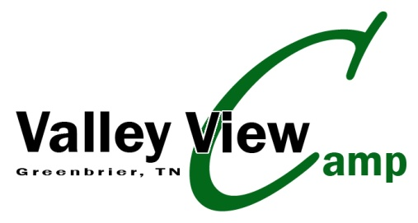

WAIVER AND RELEASE OF LIABILITY
In consideration of Valley View Camp furnishing services and/or equipment to enable me to participate in hikes, swimming, events, games and activities as follows:
I fully understand and acknowledge that; (a) risks and dangers exist in my use of the Valley View Camp property: (b) my participation in such activities and/or use if such equipment may result in my injury or illness including but not limited to bodily injury, disease strains, fractures, partial and/or total paralysis, eye injury, blindness, heat stroke, heart attack, death or other ailment that could cause serious disability: (c) these risks and dangers may be caused by the negligence of others, accidents, breaches of contract, the forces of nature or other causes. These risks and dangers may arise from foreseeable or unforeseeable causes; and (d) by my participation in these activities and/or use of equipment. I hereby assume all risks and dangers and all responsibility for any losses and/or dangers, whether caused in whole or in part by the negligence or other conduct of the owners, agents, officers, employees of Valley View Camp, or by any other person.
I, on behalf of myself, my personal representatives and my heirs, hereby voluntarily agree to release, waive, discharge, hold harmless, defend, and indemnity Valley View Camp and its owners, agents, officers, and employees from any and all claims, actions, or losses for bodily injury, property damage, wrongful death, loss of services, or otherwise which may arise out of my use of the property or my participation in any or all activities. I specifically understand that I am releasing, discharging, and waiving any claims or actions that I may have presently or in the future for the negligent acts or other conduct by the owners, agents, officers or employees of Valley View Camp. This waiver is good through 10/31/2011.
MEDICAL PERMISSION AUTHORIZATION
If the participant is of minority age, the undersigned parent of guardian hereby gives permission for Valley View Camp to authorize emergency medical treatment as may be deemed necessary for the child named below while participating in camp activities or their stay on camp property.
I HAVE READ THE ABOVE WAIVER AND RELEASE AND BY SIGNING IT AGREE IT IS MY INTENTION TO EXEMPT AND RELIEVE VALLEY VIEW CAMP FROM LIABILITY FOR PERSONAL INJURY. PROPERTY DAMAGE OR WRONGFUL DEATH CAUSED BY NEGLIGENCE OR ANY OTHER CAUSE.
____________________________________________________________________________________
Print Name Age Date of Birth Phone
____________________________________________________________________________________
Signature Address City, State. Zip
____________________________________________________________________________________
Signature of Parent/Guardian (if less than 18 years old) Date
Email address____________________________________________________________________________
Valley View Camp Inc. 7352 Swift Rd. Greenbrier, Tn. 37073

